**Key Terms**

**Trajectory**

The trajectory is the path followed by an object (here, a person) in motion. Here, a trajectory is the set of points that refer to the position of the person at any instant of time.

Trajectory τ is the set of sequence of points P i , such that

**τ = [ P i:P i = { x i, y i, <z i>, Ti} ]**

where, **T i < T i+1**

**x i**and **y i** are the coordinates of the object in Geographics coordinate system at any instant **T i**

**Gaussian Membership Function**

Gaussian Membership Functiondefined by a central value **m** and a standard deviation **k > 0**.

This function returns the value between 0 and 1. The closer the value is to mean **m** the output will be closer to 1.

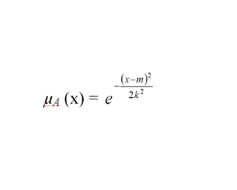

where, **m** is mean of distribution and

**k** is standard deviation of distribution

Figure 1 : Gaussian Function

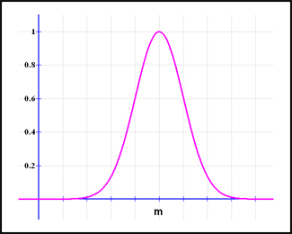

**GNSS**

GNSS stands for Global navigation satellite system. It is the generic term for satellite navigation systems that provide autonomous geo-spatial positioning with global coverage. For Example, GPS ( Global Positioning Service ), GLONASS ( Globanaya Navigazionnaya Sputnikovaya Sistema ) ( Russian version of the American GPS ), and China’s BEIDOU. India is also developing the IRNSS( Indian Regional Navigation Satellite System ) with an operational name of NAVIC( Navigation with Indian Constellation ).

**GIS**

GIS stands for Geographic Information System. It is a system that is designed to capture, store, manipulate, analyse, manage and visualize the spatial or geographic data. For Example ArcGIS, QGIS, GRASS GIS are most popular.

Fig1. Trajectory Data Presented on Google Maps

